SP2 Proposal

Game Name: Re:Pink

Team : Pink Cats

Members:

Clement

Wai Men

Glenda

Jeri

Val

**Index:**

**Description:** **3**

**Feature List:** **3**

**UI:** **4**

**Controls:** **5**

**Task Breakdown:** **6**

**Project Schedule:** **7**

**Unique Selling Point:** **7**

# Description:

* ***Re:Pink*** features a futuristic car showroom where players get to choose between the 4 amazing futuristic cars displayed. They can take each car for a test drive or play mini games such as Flappy Car and Car Surfers!

# Feature List:

* **Cameras**
  + **First Person Camera** 
    - First Person Camera will be available in the selection screen where players are able to move around and choose between which car they would want to use and which mini game they would want to play with their car.
  + **Third Person Camera**
    - Third Person Camera will be available in test drive, where players will be able to drive around in the car.
* **Test driving**
  + Environment: Mario Kart Rainbow Road
  + Camera: 3rd Person

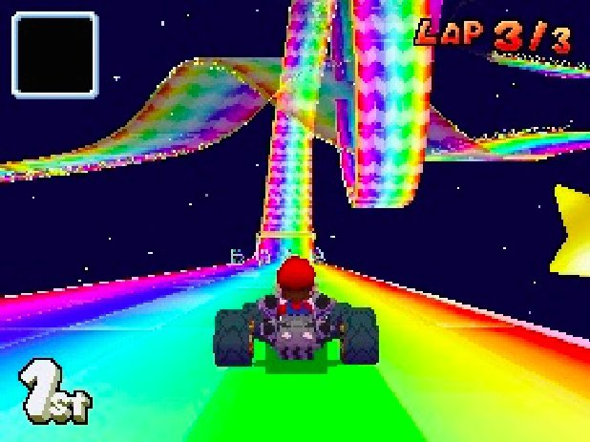

* + Car is able to use nitro boost (with cooldowns)
  + Breaking for when car is moving and controls are not pressed
  + Car can fall off the track
    - But will be teleported back onto its last landed position when it falls off
* **Mini Games**
  + **Flappy Car**
    - Player have to guide a flying car through holes in walls
    - Player gains more points the longer they survive
    - Player can collect power ups to gain advantages
      * Slowdown Speed
      * Score Boost
      * Destroy Wall
    - All time highest score will be tracked
    - Game stops when player loses, Player can lose by:
      * Hitting a wall
      * Hitting the floor (not ceiling)
  + **Car Surfers**
    - Environment: 3 Road Lane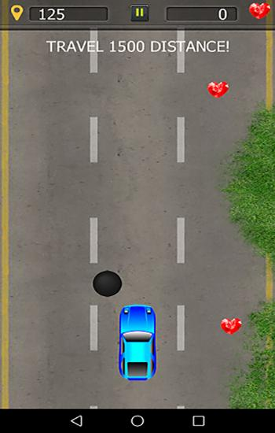
    - Car can only move left or right. Everything else will be move down (for road: using shaders to move the texture)
    - Nitro boost
      * Nitro boost will only be usable when the nitro bar is full (the bar will slowly increase after a certain amount of time)
      * Distance Travelled will be higher when boost is activated
      * Able to hit down any obstacles when activated
    - End Condition: When car hits an obstacle without boost activated
    - Score will be determined by the distance travelled
    - All time highest score will be tracked (txt file)

# UI:

* Start Menu
  + Start Game button
  + A fancy background
* Pause Menu
  + A fancy background
  + Text : “ Press Any Key to Continue”
  + Return to Start Menu button
  + Return to Selection Screen
* Diegetic Car Stats Screen
  + Data :
    - Acceleration
    - Top Speed
    - Nitro
    - Handling
  + Select button
  + Cancel button
* Test Drive
  + Velocity (speed)
  + Location
  + Nitro Boost Cooldown timer
* Mini Game
  + Flappy Car
    - Score
    - Highest Score
    - Powerup Held
  + Car Surfers
    - Score(distance travelled)
    - Highest Score
    - Nitro Bar

# Controls:

* Player Movements
  + In Selection Screen
    - W/A/S/D for moving left, right, forward and backwards
    - Mouse to adjust direction facing
  + In Test drive / Mini Games
    - Test Drive
      * W/S for moving forward and backward
      * A/D for turning left and right
      * Spacebar for using nitro boost
    - Flappy Car
      * Spacebar to Jump up
      * Right Click to use Powerup
      * Auto move to the left
    - Car Surfers
      * A/S to Move Left/Right
      * Spacebar for nitro boost (with cooldown)
      * Auto move downwards

# 

# Task Breakdown:

Clement:

|  |  |
| --- | --- |
| Task | Estimated Duration |
| Flappy Car (Minigame 1) - Textures | 2 Days |
| Flappy Car (Minigame 1) - Logics | 5 Days |
| Drive Testing Collision | 2 Days |
| Sounds | 2 days |
| Shaders | 2 days |

Wai Men:

|  |  |
| --- | --- |
| Task | Estimated Duration |
| Rendering for Selection Screen | 0.5 Day |
| Test driving - Logics | 5 Days |
| Rendering state | 0.5 Day |
| Selection of Cars for Test drive  -  implementation | 1 Day |
| Scene Transitions  -  implementation | 1 Day |
| Car Class  -  Base Code | 1 Day |
| lighting | 2 Days |
| skybox | 1 Day |
| Sound | 0.5 Day |
| Shader | 1 Day |

Glenda:

|  |  |
| --- | --- |
| Task | Estimated Duration |
| Car Surfers (Mini Game 2) - Models | 1 day |
| Car Surfers (Mini Game 2) - Logics | 4 days |
| Car Surfers (Mini Game 2)  -  Interaction with the main scene  (rendering to different state) | 2 days |
| Sounds | 2 days |
| Shaders | 2 days |

Jeri:

|  |  |
| --- | --- |
| Task | Estimated Duration |
| First Person Camera | 1 Day |
| Player Class | 1 Day |
| Car Movement | 2 Day |
| Diegetic Stat Interface | 2 Days |
| Third Person Camera | 2 Days |
| Car Class - Implementation | 1 Day |
| Player Movement | 1 Day |
| Hardware Abstraction | 2 Days |
| Singleton Data | 2 Days |
| Shader | 1 Day |

Val:

|  |  |
| --- | --- |
| Task | Estimated Duration |
| UI for Test Drive - Model n Code | 1 day |
| UI for start menu - Model n Code | 2 days |
| UI for pause menu - Model n Code | 2 days |
| UI for Selection Screen  -  Texture n Code | 2 Days |
| Test Drive - Model | 3 days |
| Mini Game Booths - Model | 2 Days |
| Space Shuttle - Model | 2 Days |

# Project Schedule:

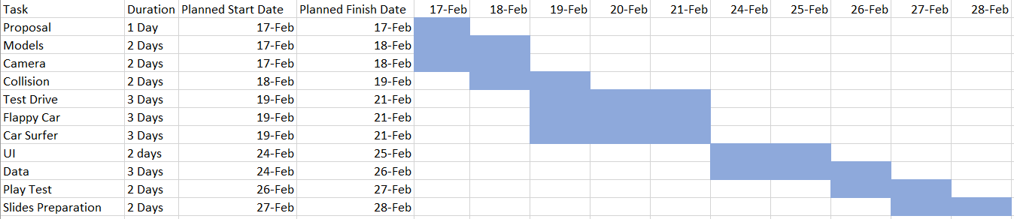

# Unique Selling Point:

INTERACTIONS :

* Space Racetrack
  + Can fall off the track
  + Test driving different car (each car has different strength eg.acceleration, handling, etc )
* Minigames
  + Various games to choose from
    - Flappy Car
    - Car Surfers